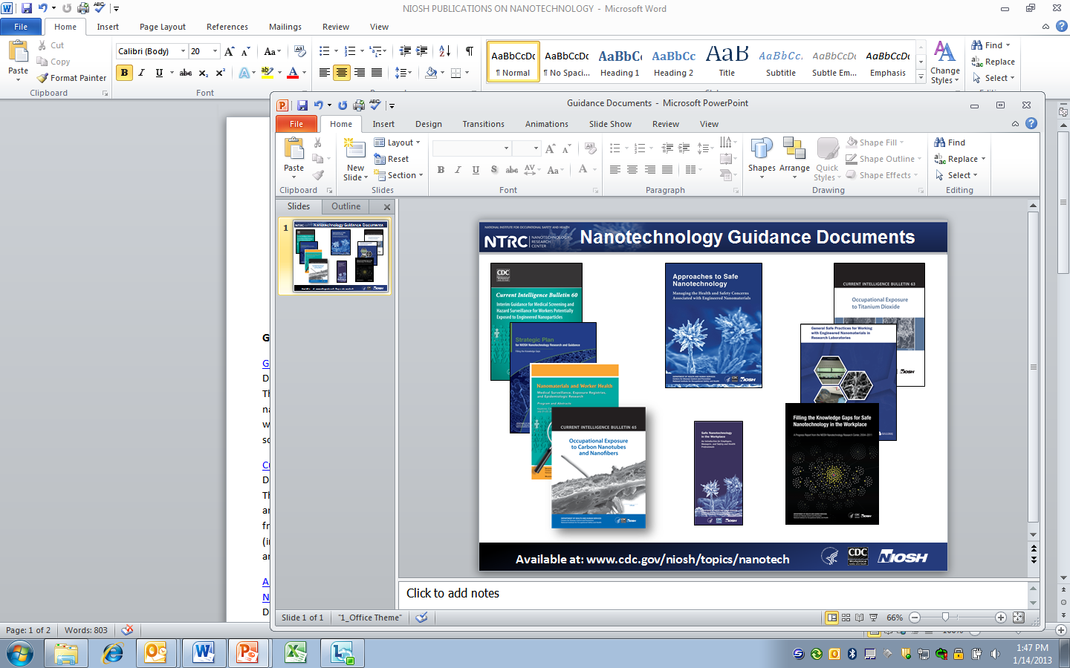

**US NIOSH PUBLICATIONS ON NANOTECHNOLOGY**

**Available at** [**www.cdc.gov/niosh/topics/nanotech/**](http://www.cdc.gov/niosh/topics/nanotech/)

**Guidance**

[Current Strategies for Engineering Controls in Nanomaterial Production and Downstream Handling Processes](http://www.cdc.gov/niosh/docs/2014-102/pdfs/2014-102.pdf)

DHHS (NIOSH) Publication 2014-102

This document is a summary of available engineering control technologies that can be used in the nanotechnology industry. While some of these have been evaluated in this industry, others have been shown to be effective at controlling similar processes in other industries. Our hope is that this document will aid in the selection of engineering controls for the fabrication and use of products in the nanotechnology field.

[Current Intelligence Bulletin 65: Occupational Exposure to Carbon Nanotubes and Nanofibers](http://www.cdc.gov/niosh/docs/2013-145/pdfs/2013-145.pdf)

DHHS (NIOSH) Publication 2013-145

This Current Intelligence Bulletin (1) reviews the animal and human data relevant to assessing the adverse health effects of carbon nanotubes (CNTs) and nanofibers (CNFs), (2) provides a quantitative risk assessment using dose-response information from the rat and human lung dosimetry modeling and recommended occupational exposure limit for CNT and CNFs, and (3) describes exposure monitoring techniques, exposure control strategies, and research needs.

[General Safe Practices for Working with Engineered Nanomaterials in Research Laboratories](http://www.cdc.gov/niosh/docs/2012-147/)   
DHHS (NIOSH) Publication 2012-147  
This document contains recommendations on engineering controls and safe practices for handling engineered nanomaterials in laboratories and some pilot scale operations. This guidance was designed to be used in tandem with well-established practices and the laboratory’s chemical hygiene plan. As our knowledge of nanotechnology increases, so too will our efforts to provide additional guidance materials for working safely with engineered nanomaterials.

[Current Intelligence Bulletin 63: Occupational Exposure to Titanium Dioxide](http://www.cdc.gov/niosh/docs/2011-160/)

DHHS (NIOSH) Publication 2011-160

This NIOSH Current Intelligence Bulletin (1) reviews the animal and human data relevant to assessing the carcinogenicity and other adverse health effects of TiO2, (2) provides a quantitative risk assessment using dose-response information from the rat and human lung dosimetry modeling and recommended occupational exposure limits for fine and ultrafine (including engineered nanoscale) TiO2, and (3) describes exposure monitoring techniques, exposure control strategies, and research needs.

[Approaches to Safe Nanotechnology: Managing the Health and Safety Concerns Associated with Engineered Nanomaterials](http://www.cdc.gov/niosh/docs/2009-125/)

DHHS (NIOSH) Publication 2009-125

This document reviews what is currently known about nanoparticle toxicity, process emissions and exposure assessment, engineering controls, and personal protective equipment. This updated version of the document incorporates some of the latest results of NIOSH research, but it is only a starting point. The document serves a dual purpose: it is a summary of NIOSH's current thinking and interim recommendations; and it is a request from NIOSH to occupational safety and health practitioners, researchers, product innovators and manufacturers, employers, workers, interest group members, and the general public to exchange information that will ensure that no worker suffers material impairment of safety or health as nanotechnology develops.

[Interim Guidance for Medical Screening and Hazard Surveillance for Workers Potentially Exposed to Engineered Nanoparticles](http://www.cdc.gov/niosh/docs/2009-116/) DHHS (NIOSH) Publication No. 2009-116

This document was developed to address concerns about whether workers exposed to engineered nanoparticles will be at increased risk of adverse health effects and whether medical screening or some other type of occupational health surveillance is appropriate for these workers. Although increasing evidence indicates that exposure to some engineered nanoparticles can cause adverse health effects in laboratory animals, insufficient medical evidence exists at this time to recommend the specific medical screening of workers potentially exposed to engineered nanoparticles.

[Safe Nanotechnology in the Workplace](http://www.cdc.gov/niosh/docs/2008-112/) DHHS (NIOSH) Publication No. 2008-112

This brochure provides an introduction to nanotechnology in the workplace for employers, managers, and safety and health professionals. It addresses the following questions: Are nanoparticles hazardous to workers? How can workers be exposed? Can nanoparticles be measured? Can worker exposures be controlled?

[NIOSH Nanotechnology Field Research Effort Fact Sheet](http://www.cdc.gov/niosh/docs/2008-121/)  
DHHS (NIOSH) Publication No. 2008-121  
Information for producers and manufacturers working with engineered nanomaterials (1 to 100 nm) who are interested in participating in a cost-free, on-site assessment. As part of its nanotechnology research agenda, NIOSH created a field research team to assess workplace processes, materials, and control technologies associated with nanotechnology and conduct on-site assessments of potential occupational exposure to a variety of nanomaterials.

**NIOSH Publications**

The following NIOSH publications provide useful information about the NIOSH nanotechnology program.

[Protecting the Nanotechnology Workforce: NIOSH Nanotechnology Research and Guidance Strategic Plan 2013-2016](http://www.cdc.gov/niosh/docs/2014-106/pdfs/2014-106.pdf)

DHHS (NIOSH) Publication 2014-106

This plan updates the NIOSH Nanotechnology Research Center strategic plan for 2013-2016 using knowledge gained from the 2013 Progress report. This Strategic Plan is the roadmap being used to advance basic understanding of the toxicology and workplace exposures involved so that appropriate risk management practices can be implemented during discovery, development, and commercialization of engineered nanomaterials. NIOSH will strive to remain at the forefront of developing guidance that supports and promotes the safe and responsible development of such a promising technology.

[Filling the Knowledge Gaps for Safe Nanotechnology in the Workplace: A Progress Report from NIOSH Nanotechnology Research Center, 2004-2011](http://www.cdc.gov/niosh/docs/2013-101/pdfs/2013-101.pdf) DHHS (NIOSH) Publication No. 2013-101

This document summarizes NIOSH’s progress and program accomplishments of the NTRC from its inception in 2004 through 2011. It includes an analysis of the progress made toward accomplishing the goals and objectives of the NIOSH Strategic Plan for Nanotechnology Research and toward addressing the goals and research needs identified in the U.S. National Nanotechnology Initiative (NNI) Environmental, Health, and Safety (EHS) research strategy.

**Search Results for Nanotechnology**

[NIOSHTIC-2](http://www2a.cdc.gov/nioshtic-2/) is a searchable bibliographic database of occupational safety and health publications, documents, grant reports, and journal articles supported in whole or in part by NIOSH. [www.cdc.gov/niosh/pubs/default.html](http://www.cdc.gov/niosh/pubs/default.html)